Different ways to connect EC2 instance

-Connecting EC2 instance with the Access key and Secert key in AWS console

-Connecting through SSH with keypair name

-Connecting through Session manager in aws console

-Connecting through EC2 instance connect in aws console

Linux Commands

1. man - man command will display the manual of commands with options

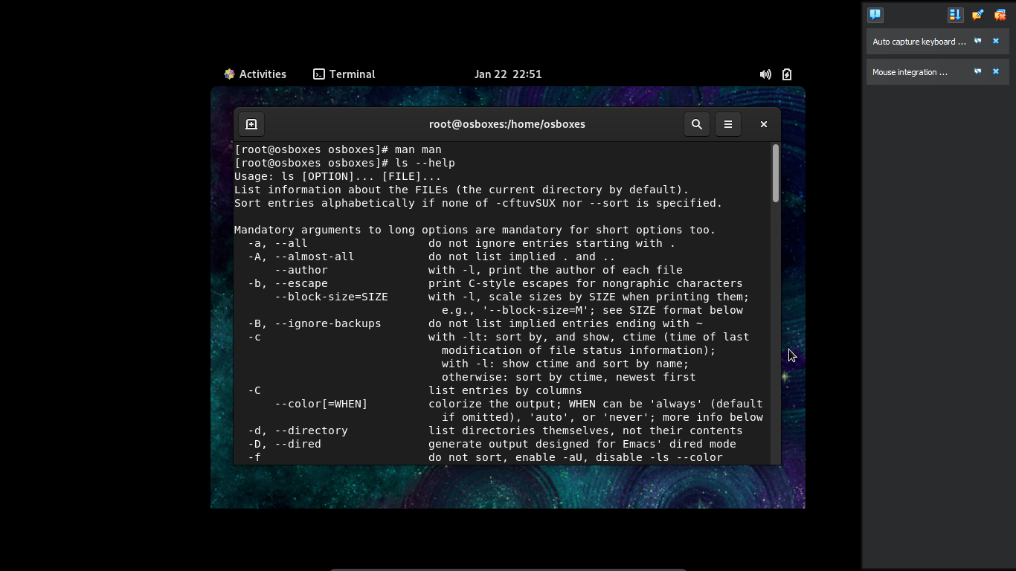

2. ls -to list all the file and folders



3. cd - to change directory

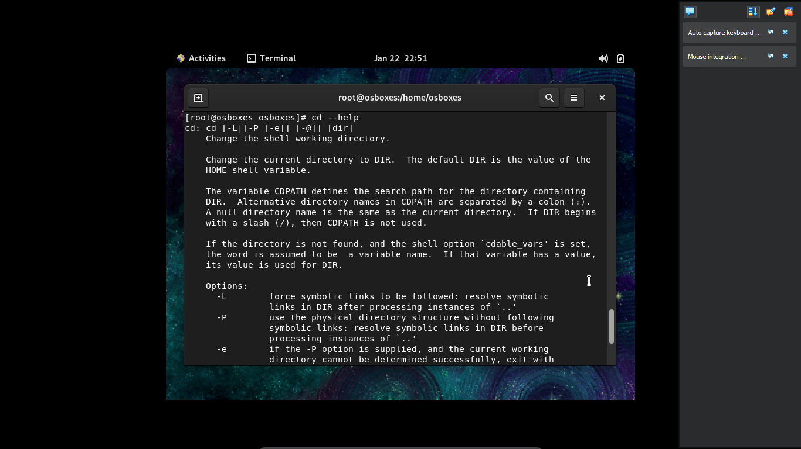

4. mkdir - to create folder

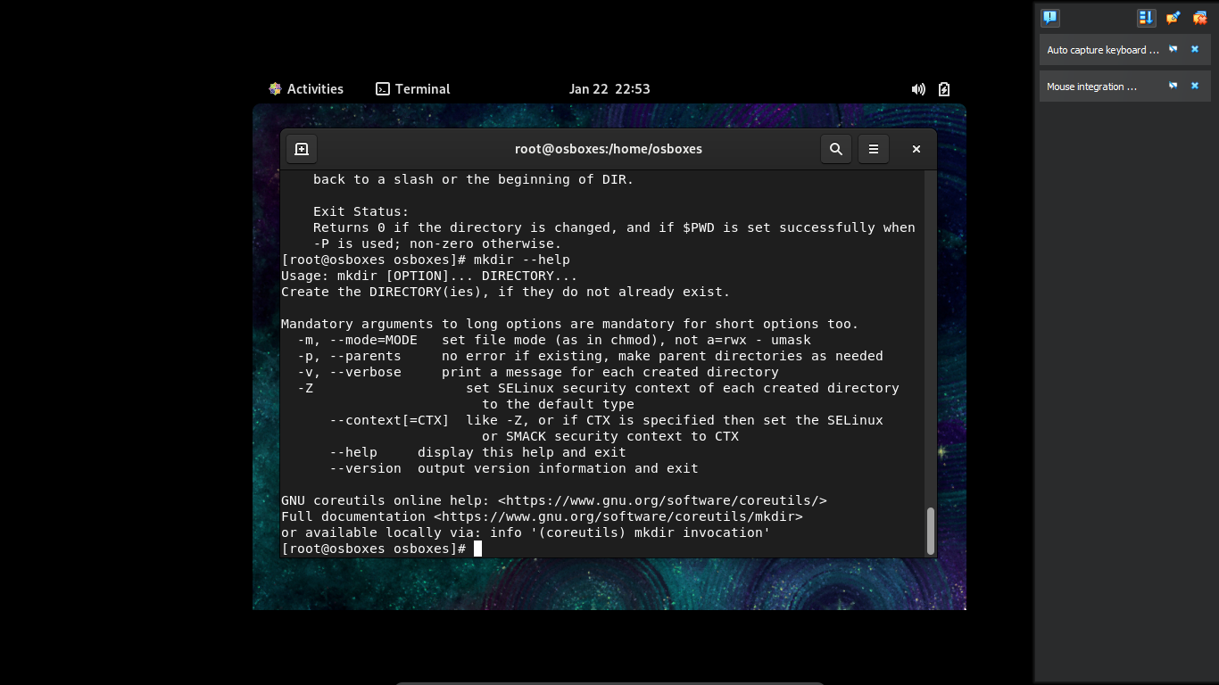

5. rmdir - to delete folder

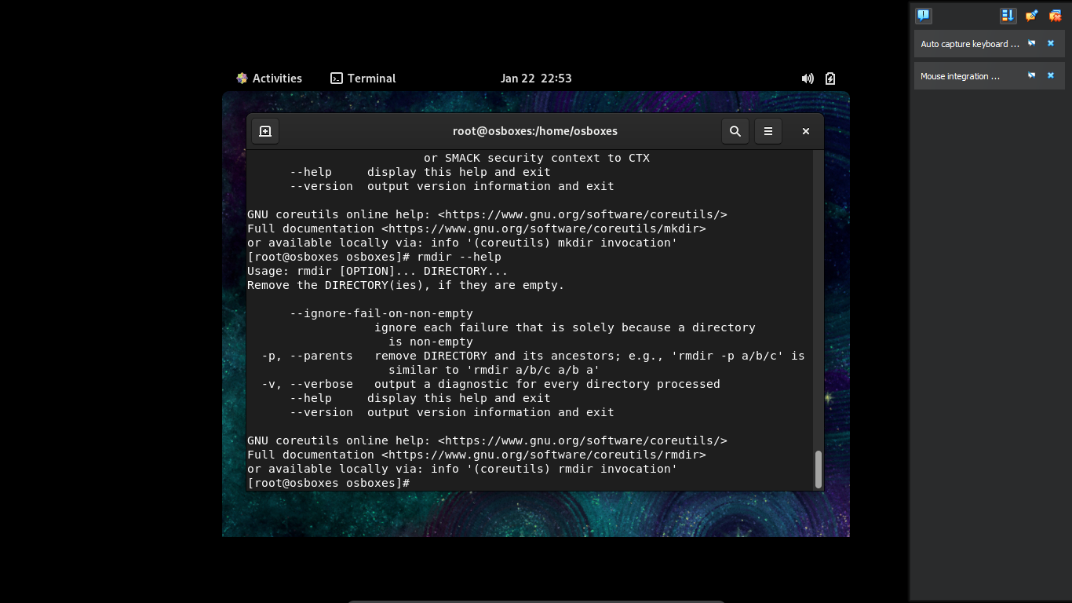

6. touch - to create empty file

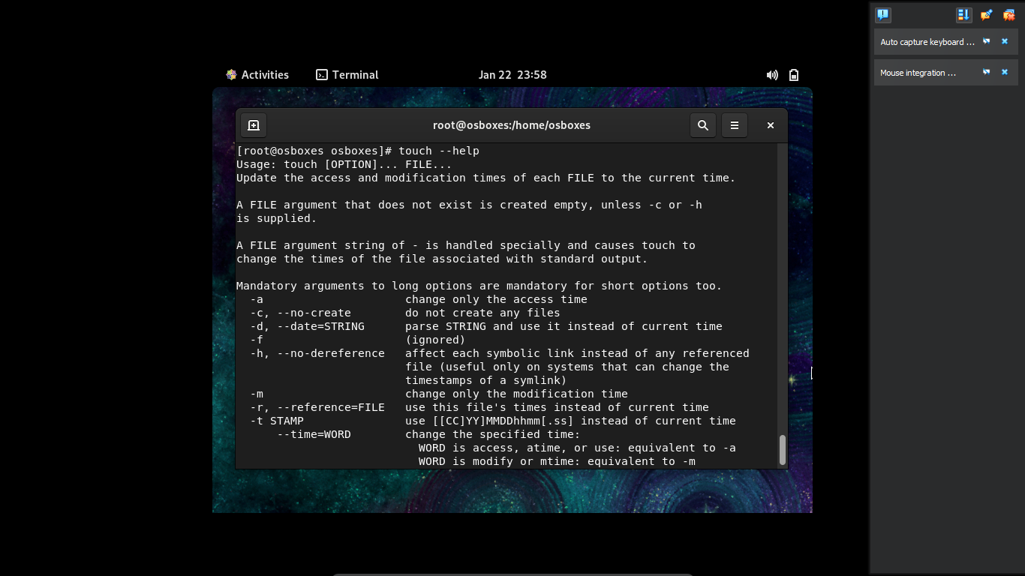

7. pwd- to view current folder path

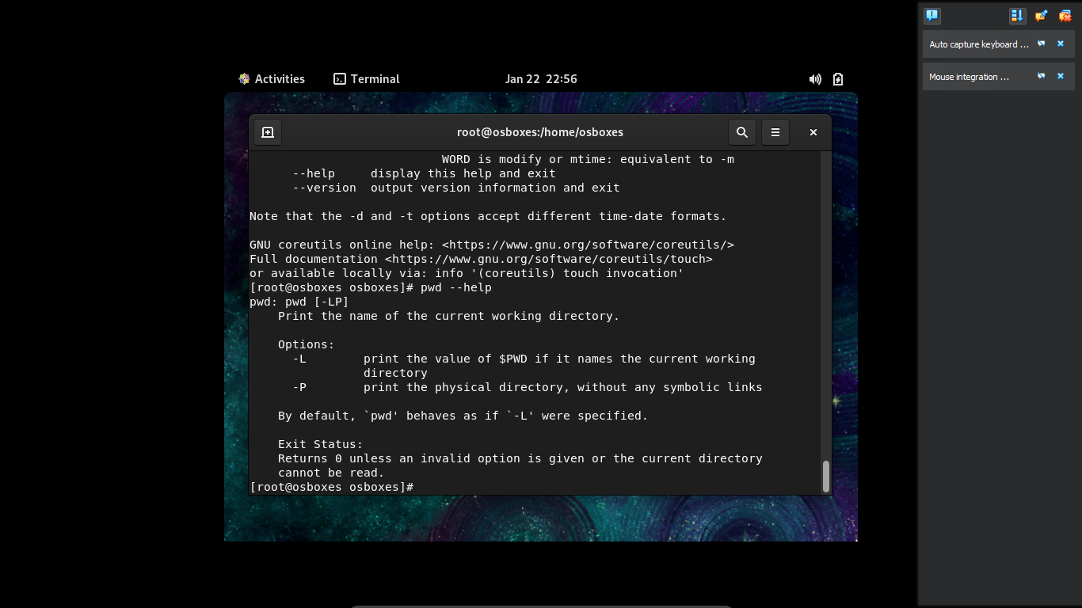

8. mv - to move the file or rename the file

i.e to move mention source file and destninaltion folder , to rename mention current file and new file name

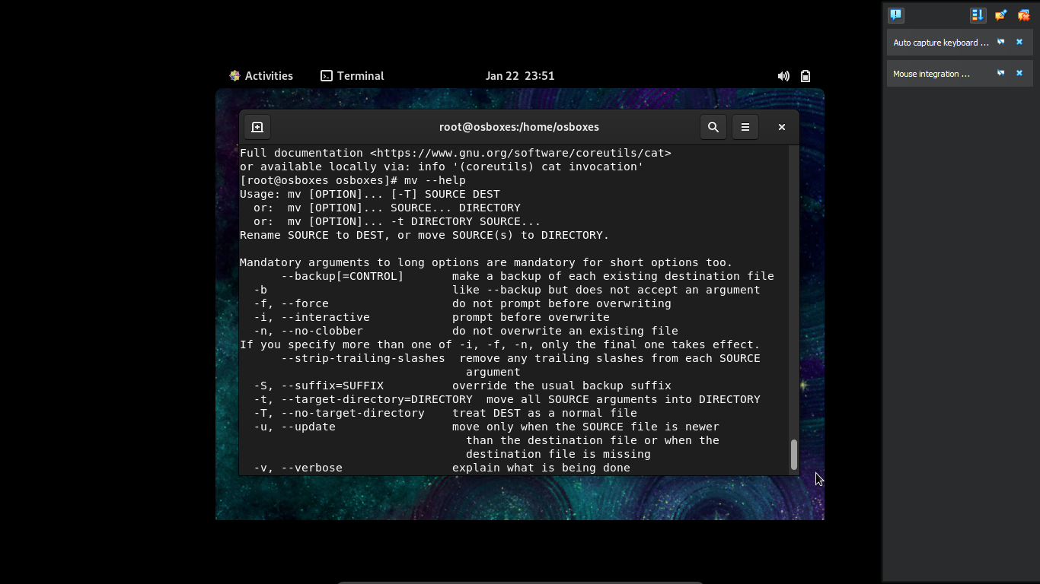

9. cp - to copy the file

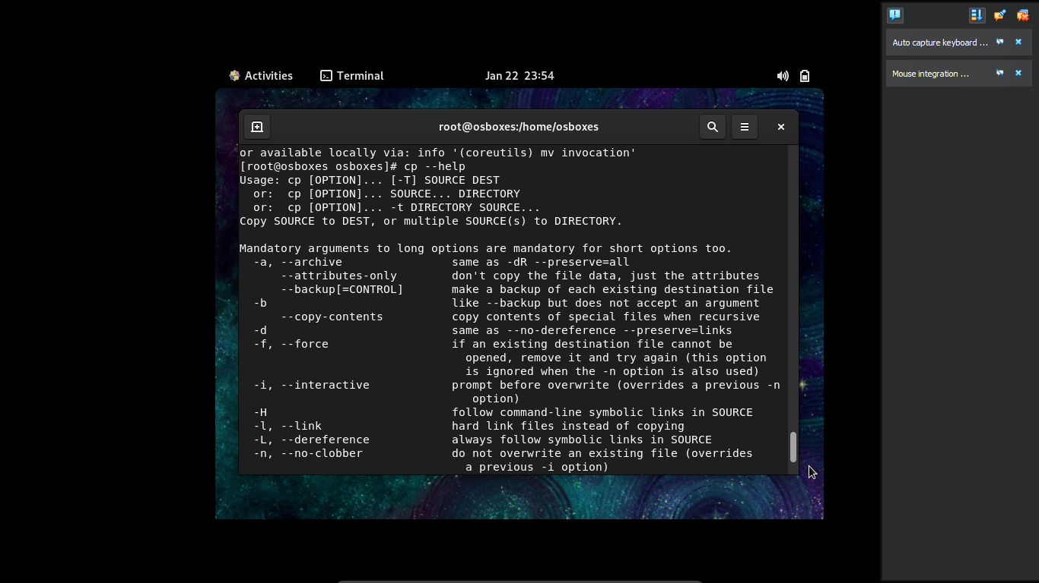

10. cat - Display the content of file

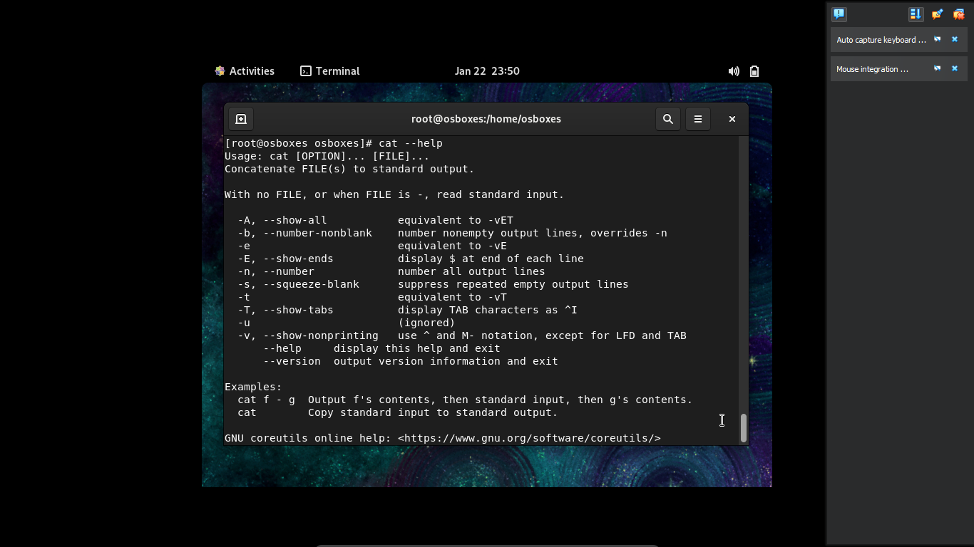

11. Sudo - to login as root user

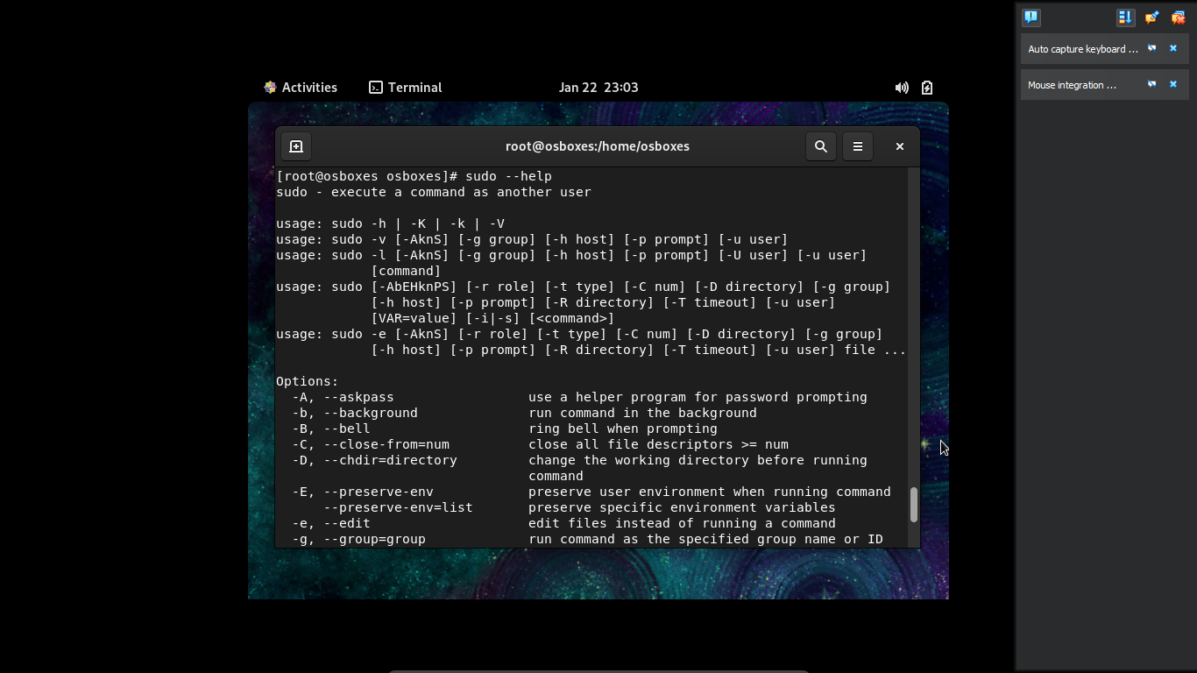

12. su - to switch the user

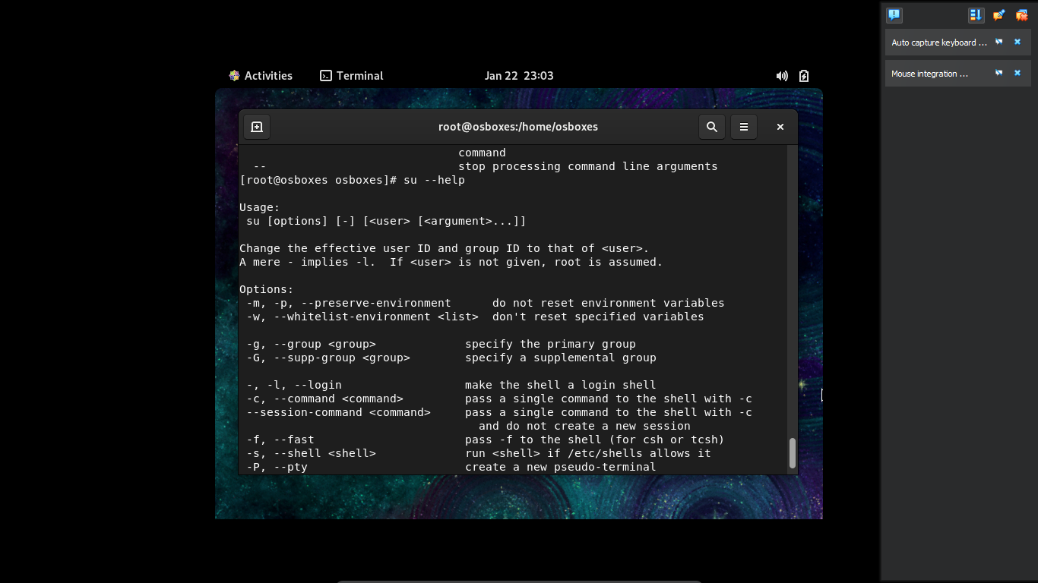

13. echo - to display the message of command

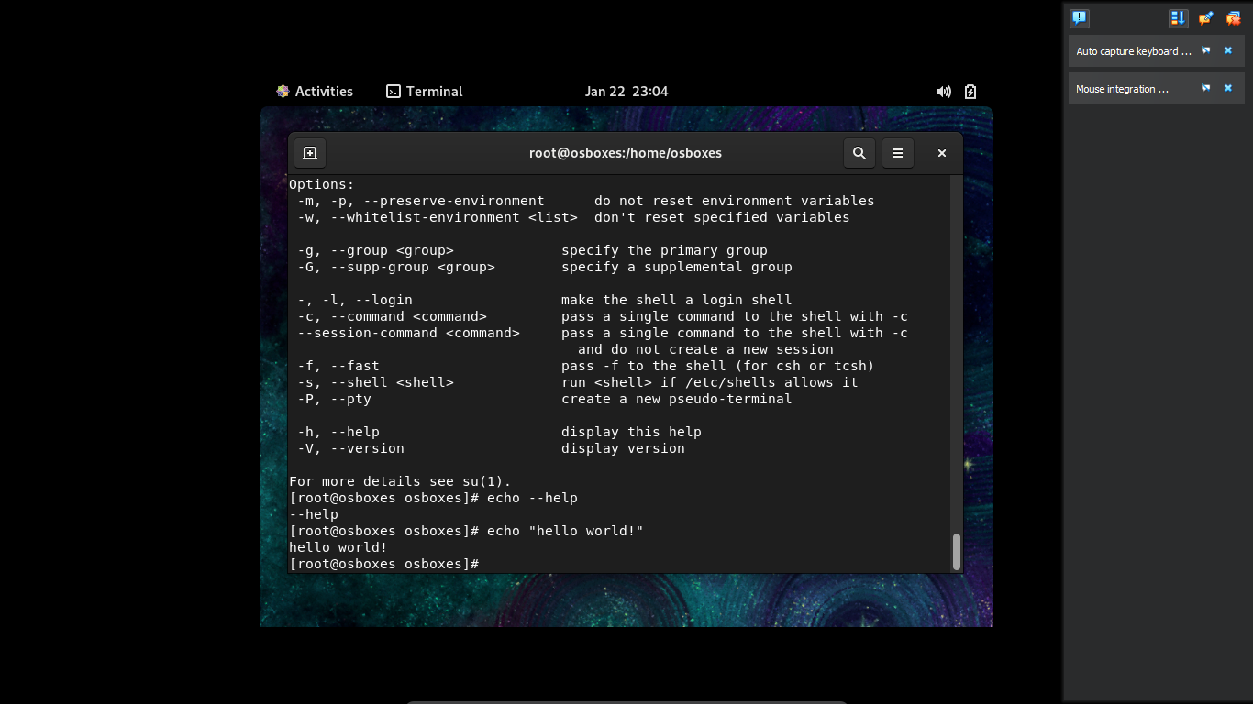

14. chmod - change the file permission

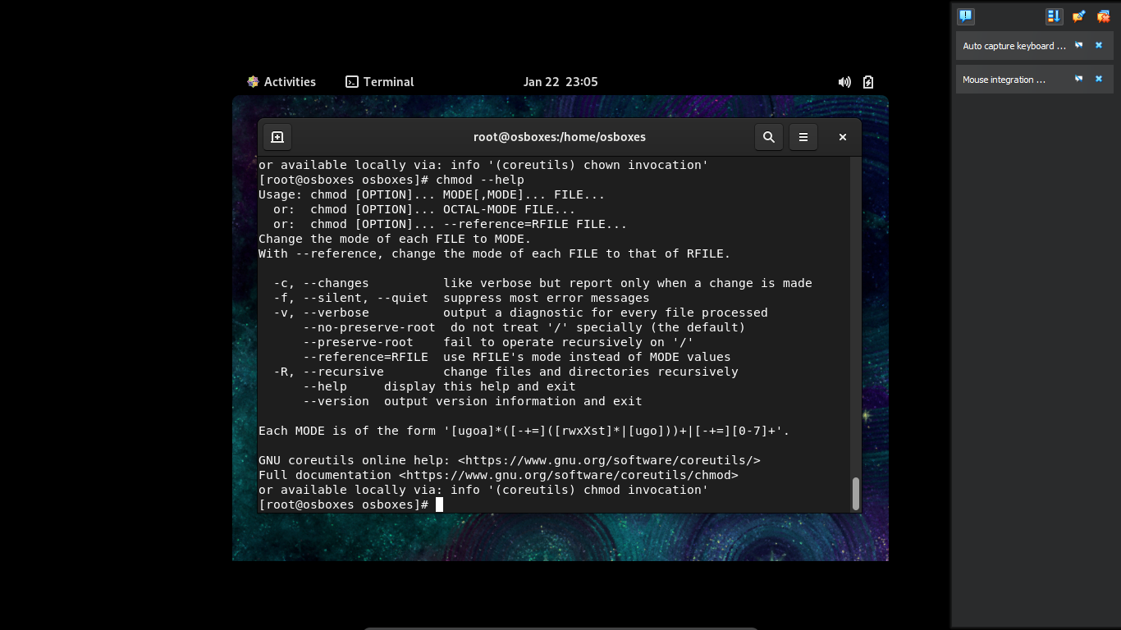

15. chown - change the owner of the file or directory

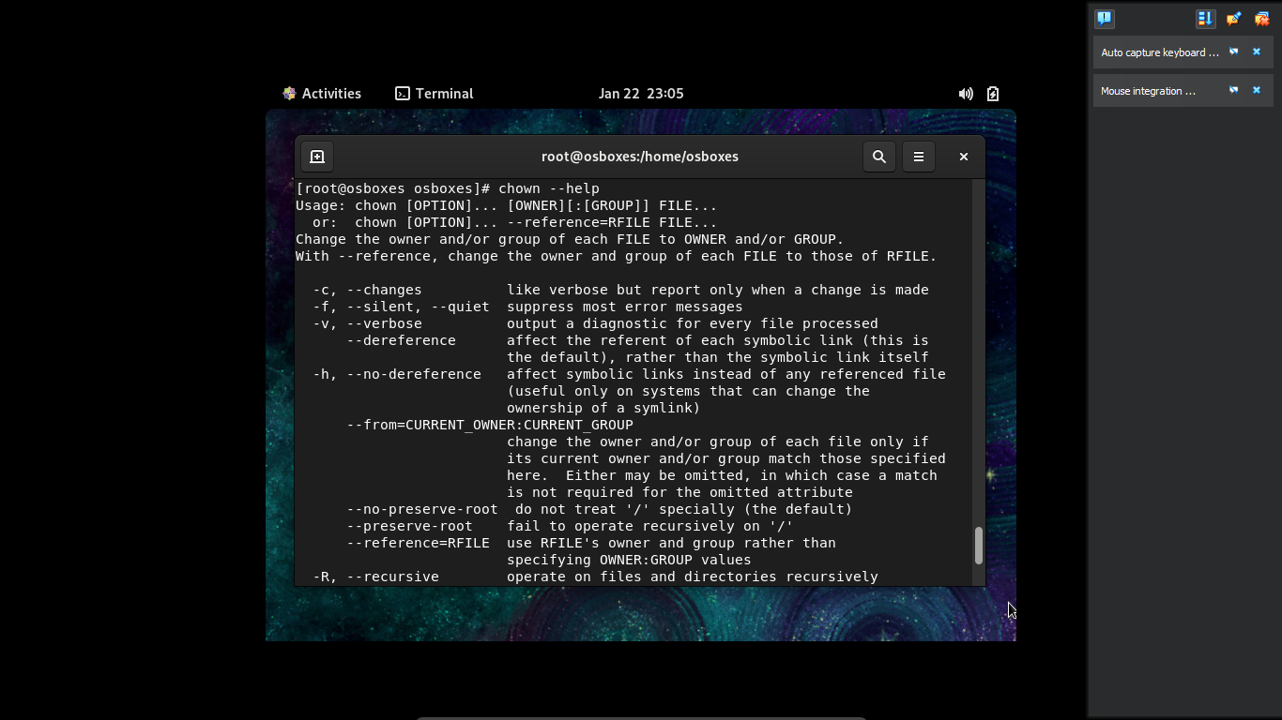

16. ps - show the running process

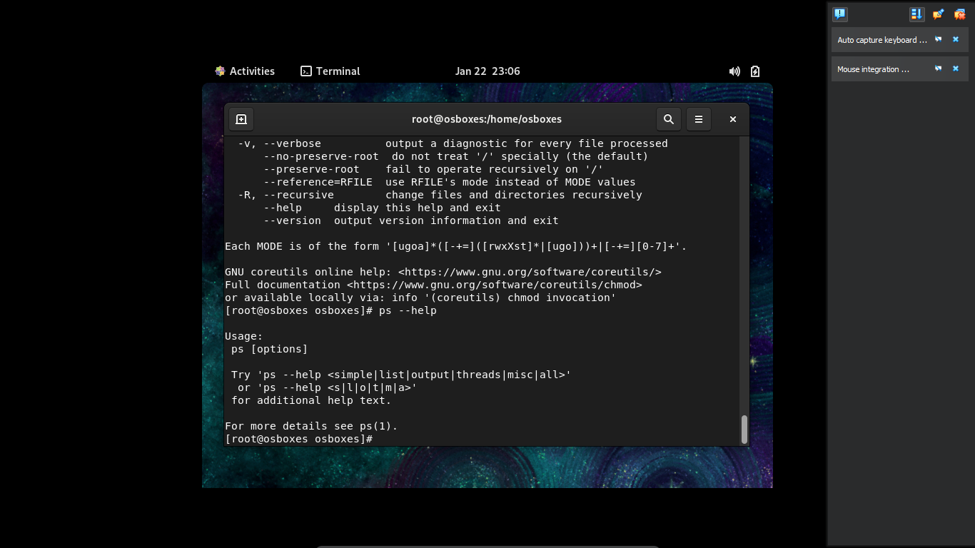

17. kill - kill the process with help of process ID

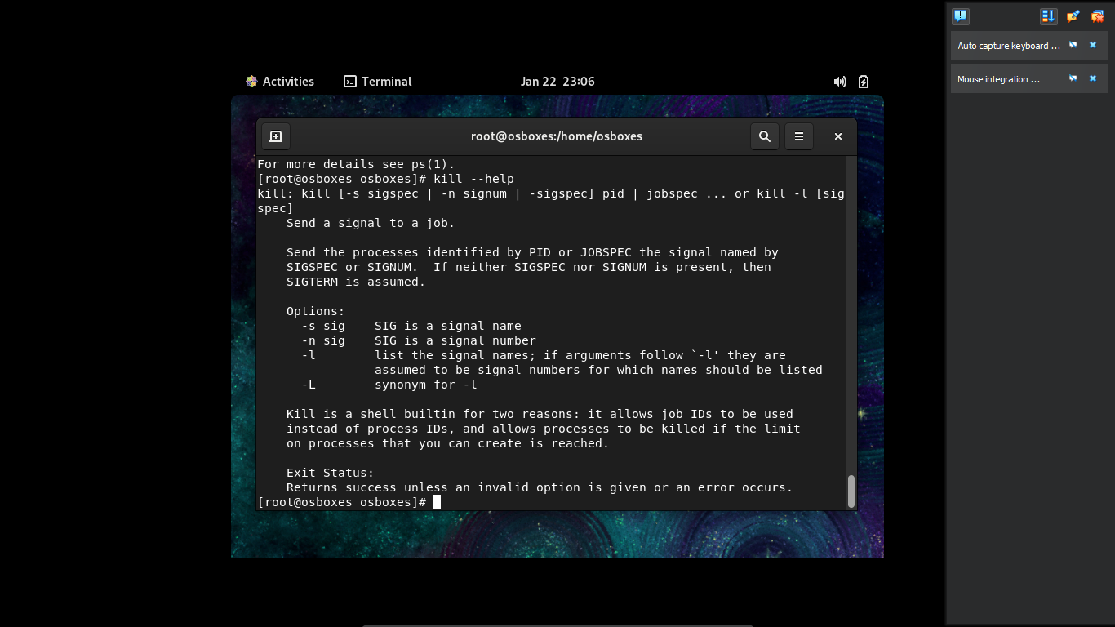

18. wget - to retrive the file from internet

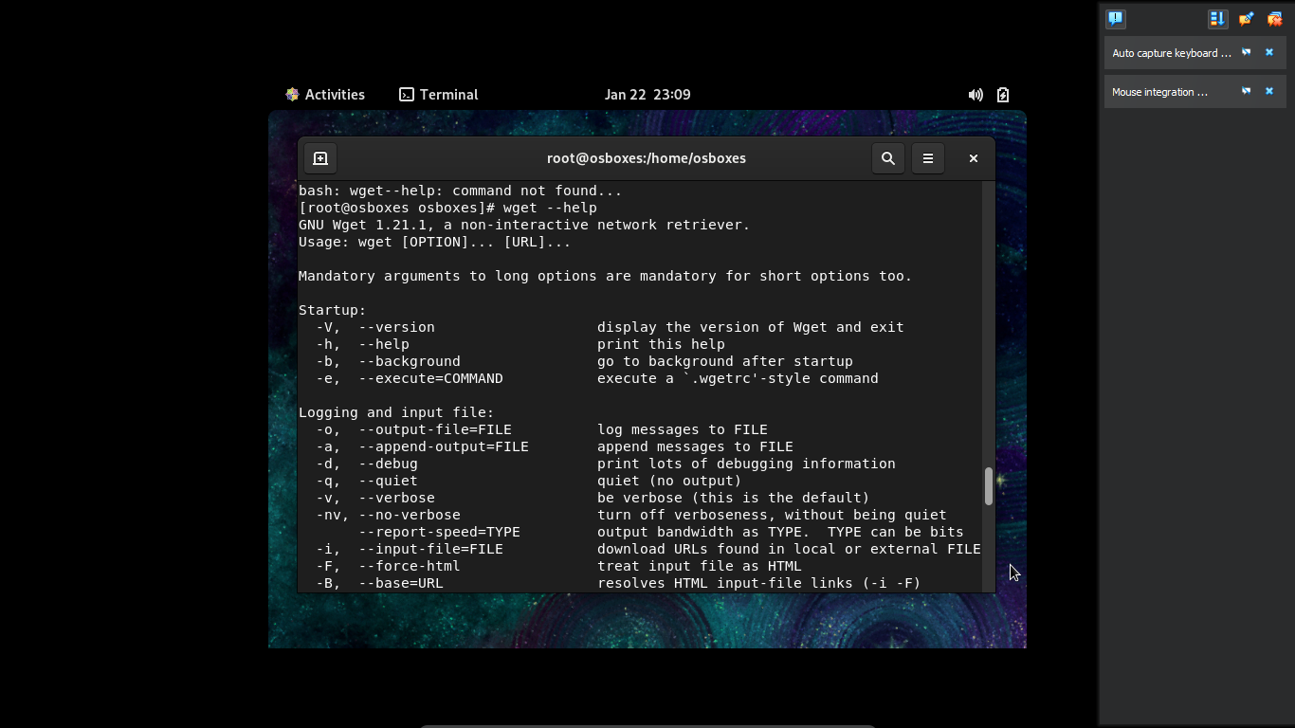

19. curl - to download the data from internet

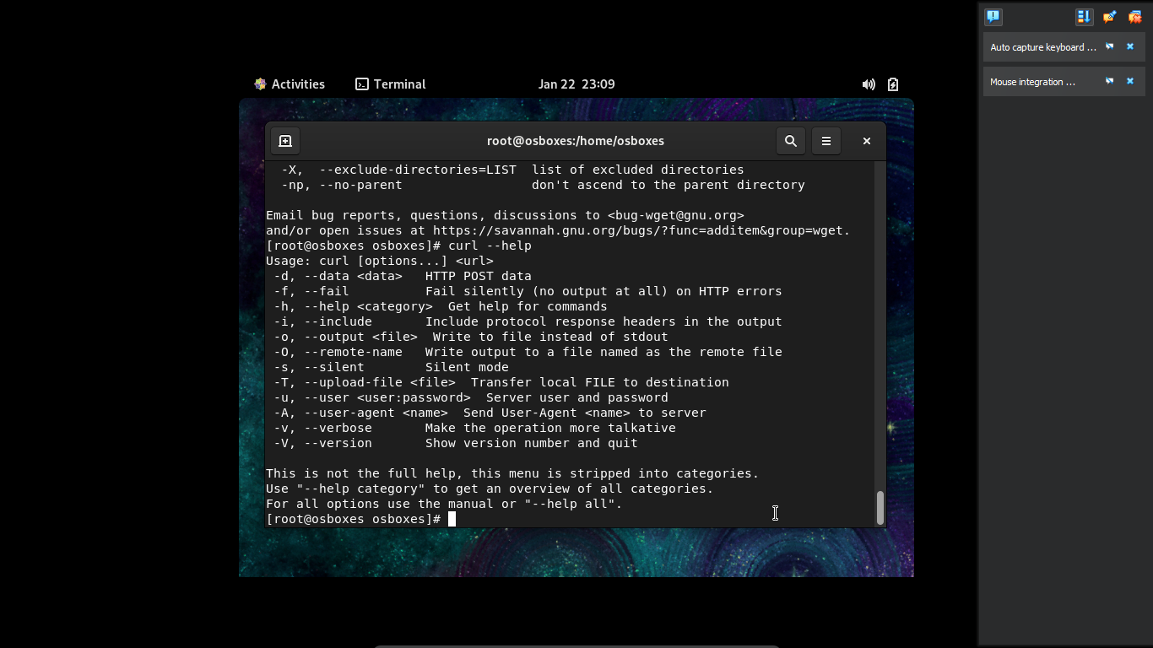

20. Date - shows the today date

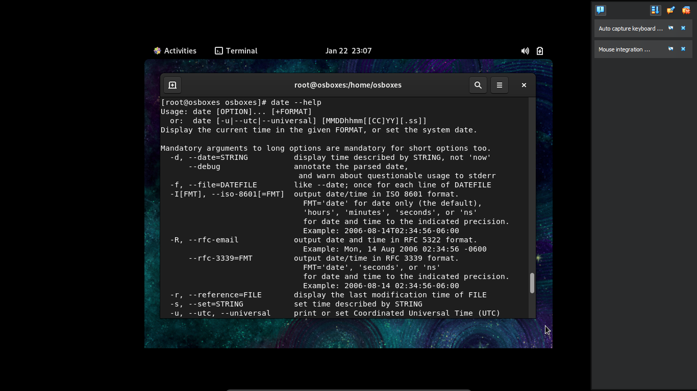

21. uptime -shows the uptime

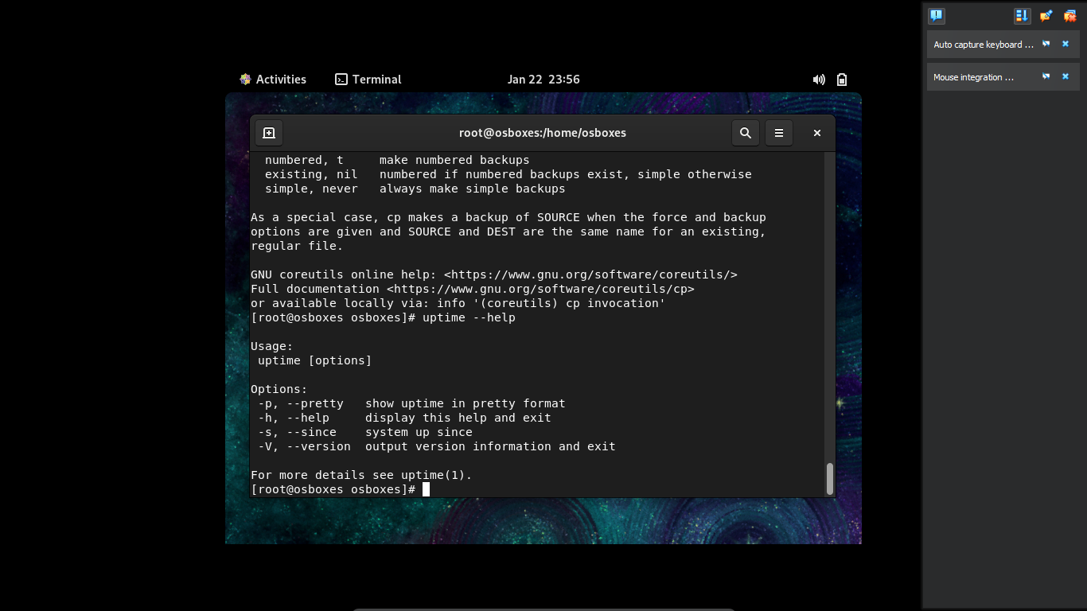

22. vi - opens the editor to edit the file

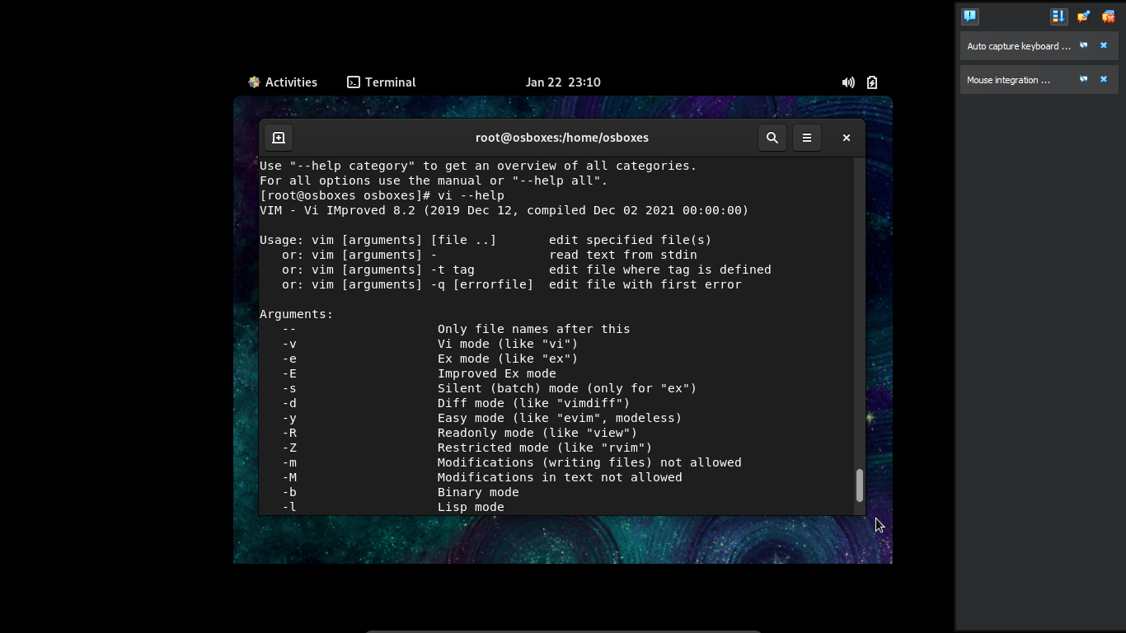

23. History - shows the history of commands

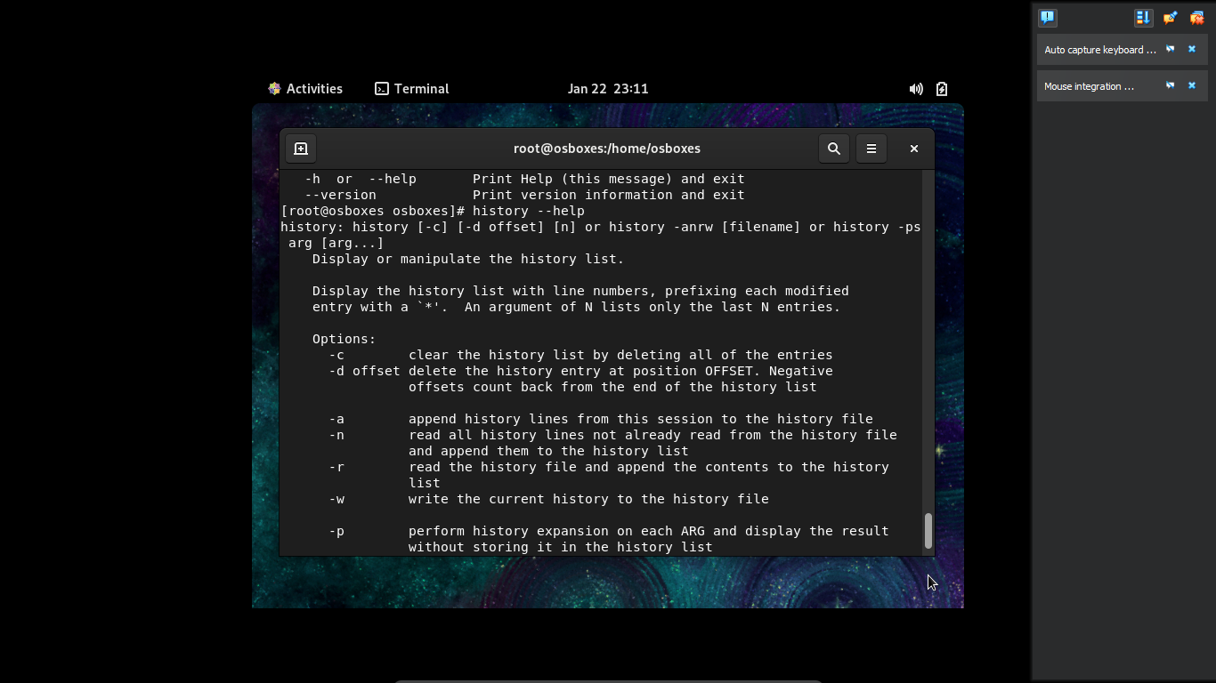

24. ping - test the reachability of the website

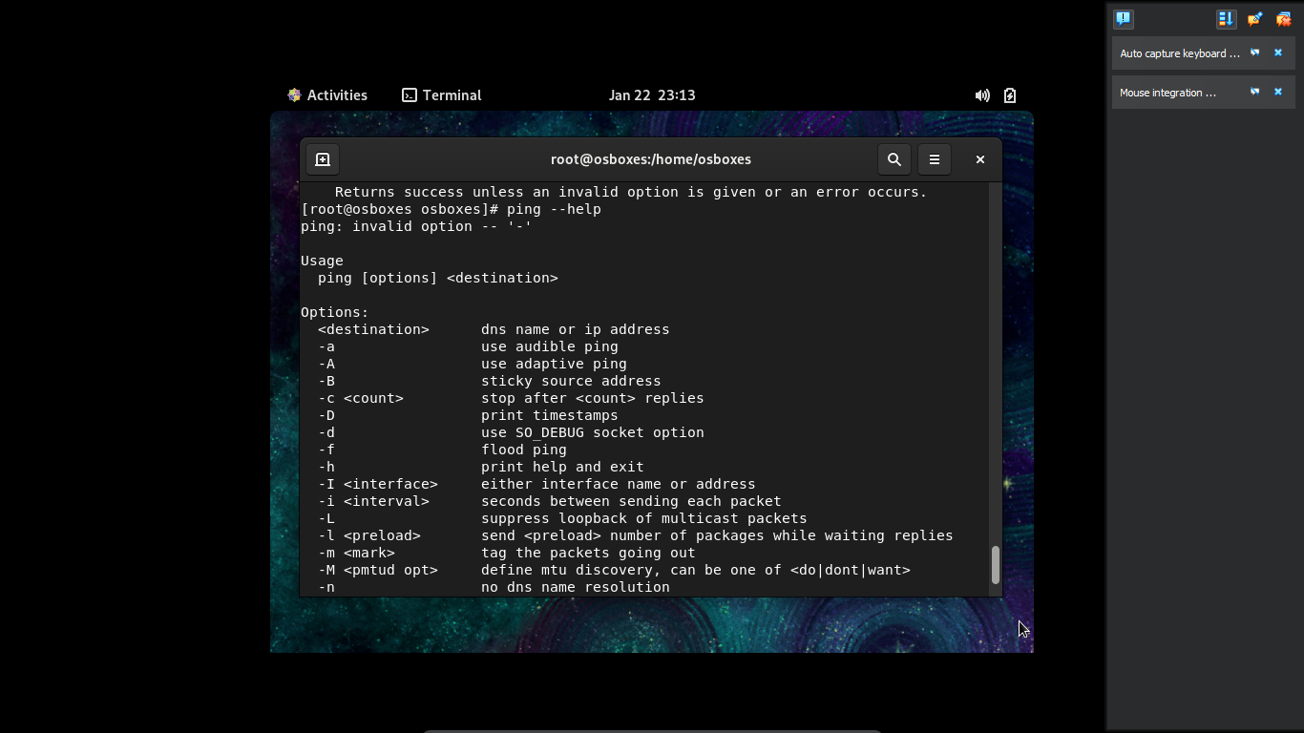

25. ip addr show - display the ip address

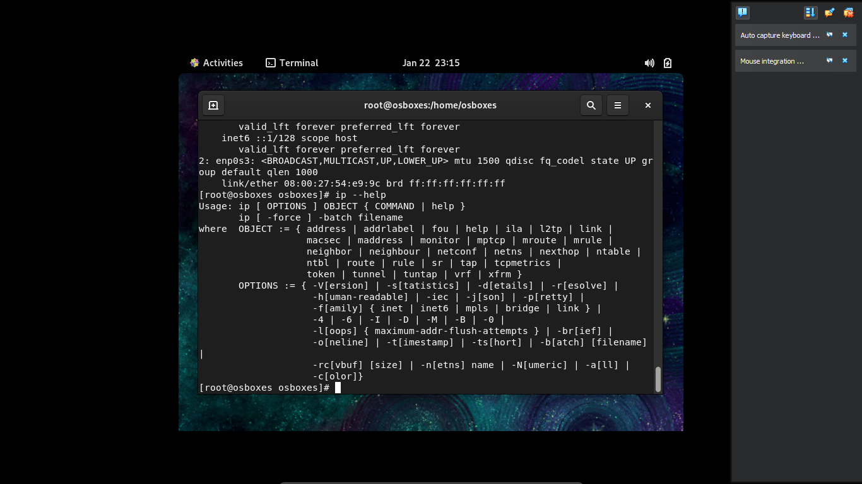

26. At - schedule task for only one time

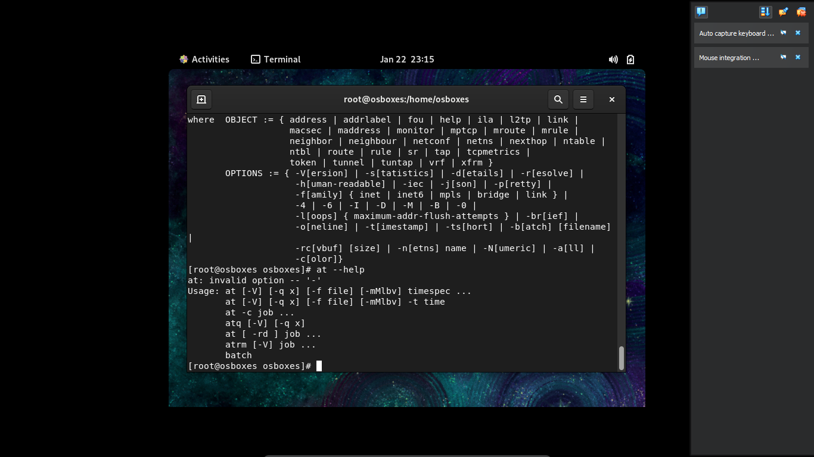

27. corntab - Schedule task for multiple time

28. yum - to install packages

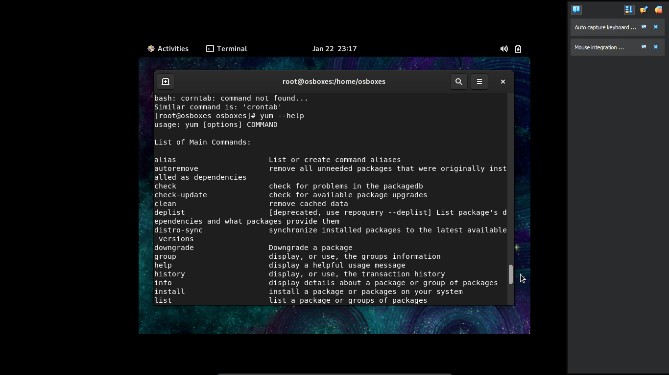

29. tar zip - to compress into zip file

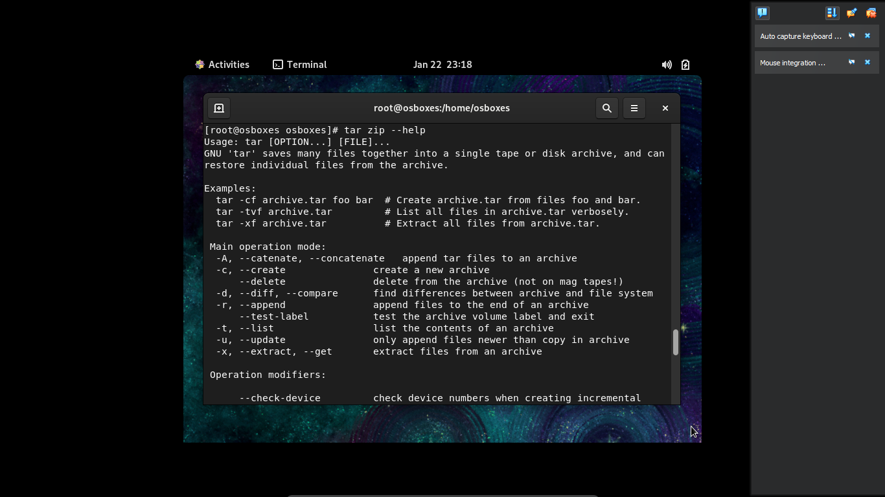

30. clear - clears the screen

